Return Address 1
Return Address 2
Date
Provider Name
Address 1
Address 2
City, State Zip Code

Re: UnitedHealthcare Dual Complete® (H0217- 014) plan launched in your area on Jan. 1, 2019
Dear <Provider Name>:
On behalf of UnitedHealthcare Community Plan of Connecticut, we’d like to thank you for being part of the UnitedHealthcare Dual Complete® (PPO SNP) Medicare Advantage network.

The UnitedHealthcare Dual Complete® Medicare Advantage plan started in your area on Jan. 1, 2019, for members who are currently eligible for both Medicaid and Medicare and enrolled in the state’s Medicaid program. We’re pleased to be offering this Dual Special Needs Plan (DSNP) in Connecticut.

To help you identify these members, look for this member ID card.

UnitedHealthcare Dual Complete®

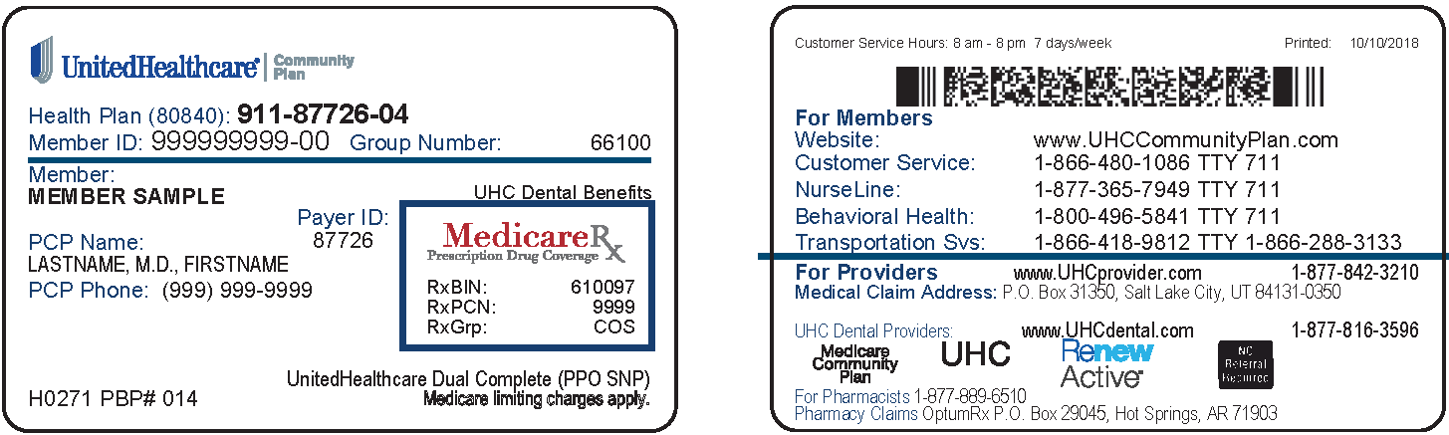

Sample member ID cards for illustration only; actual information varies depending on payer, plan and other requirements.

Learn more about the UnitedHealthcare Dual Complete® plan.
We want to make sure you have all the necessary information to see UnitedHealthcare Dual Complete® members. We’ve included several documents to help you understand how this new plan works:
- Provider Quick Reference Guide
- Provider FAQ
To learn more about this new plan, visit UHCprovider.com/CTcommunityplan > UnitedHealthcare Dual Complete® Special Needs Plans.

Care Provider Medicaid Enrollment

As a reminder, the state requires that all health care professionals and facilities are enrolled with the Connecticut Medicaid program before they can bill for Medicare cost share charges. You can learn more about the Connecticut Medicaid program at ct.gov/hh > For Providers.

We’re Here to Help
If you have questions, please contact Provider Services at 877-842-3210. Thank you.

Sincerely,

Debra Kaplan-Lewis
Health Plan Chief Executive Officer, Connecticut

Enclosures

